Week 7 (Lesson #2)- Compositional scaffolding Worksheet

THEMES

Perfect 5th interval

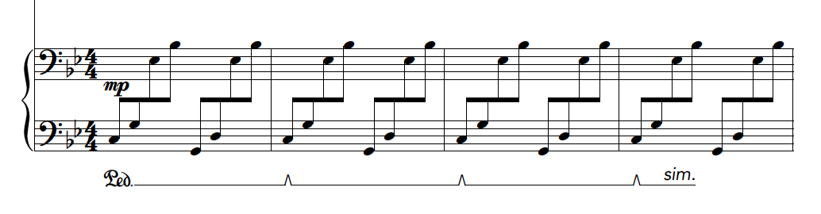

Representation of home and The brother

Light and weight

Example 1:
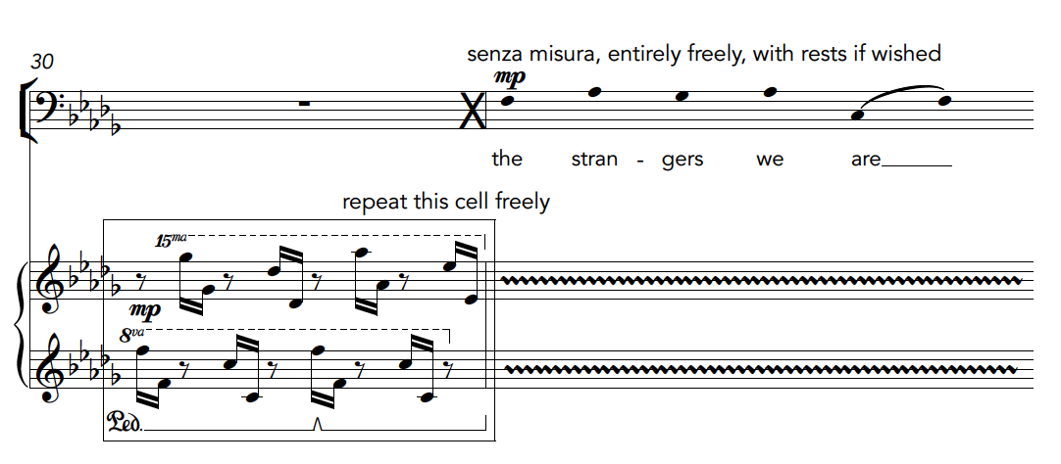

The freedom in this excerpt could be used to explore ideas of weight
*Longer/sustained = more heavy
*Faster/ridged = lighter

Example 2:
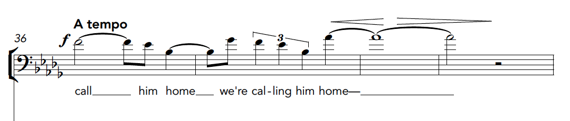

The High register represents the mothers perspective or voice
Register could also represent light and weight
*Lower register = heaviness
*Higher register = lightness

Extended techniques

Example 1:

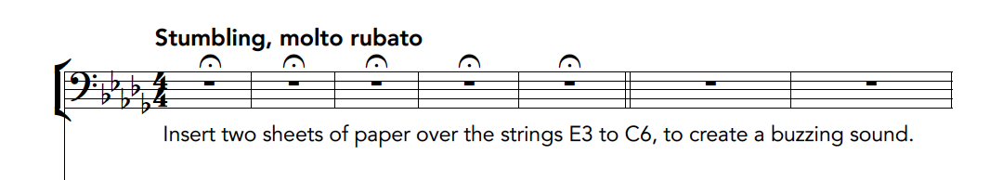

Piano (bowing the strings, playing them with mallets, plectrums, playing harmonics, and so on

Example 2:

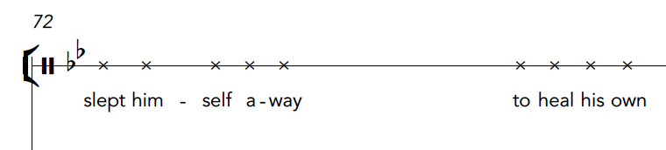

Sprechstimme in the voice- shown through X notation

